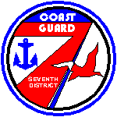 Flight Safety News
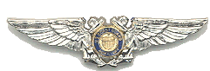
USCG Auxiliary, District 7
December 2008

The Impossible Turn

Here is a quiz question for all pilots. If you need to turn back to the airport following an engine failure do you (a) execute a 180 degree turn or (b) perform a 270 degree turn (followed by a further turn to line up with the runway)? A little thought and a simple diagram will tell you that a 180 degree turn will put you on a parallel track to the departure runway offset .25 nm to more than 1 nm depending on your aircraft’s turning radius, airspeed, bank angle and effective cross wind. The answer is 270 degrees with a further turn to line up. That is a lot of maneuvering for a low performance “glider” at low altitude.
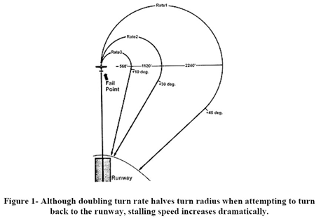
So why do pilots turn back following a partial or total engine failure? The answer seems to be pilot ego augmented by the overwhelming instinct to prevent damage to the aircraft. In attempting to avoid damage to the aircraft the aircraft stalls and falls to earth. That maneuver is often fatal.

Let’s look at the problem. First, in the event of an engine failure at or near rotation speed the aircraft will experience a rapid deceleration right down to the stall speed. In one test of a Cessna 172 SP it took only 5 seconds to go from the Vy of 74 knots down to the stall speed. Considering 2-3 seconds for the “…it can’t be happening denial” that leaves 2-3 seconds for the pilot to push the yoke or stick forward – briskly.

Don’t try this at home (or anywhere else) at low altitude. DO NOT PRACTICE SIMULATED ENGINE FAILURES AT TAKE-OFF except at altitude. Climb up to above 4,000 feet AGL, enter a take-off climb, at take-off flap configuration and retard the throttle. Notice how quickly the airspeed decays and how much forward stick pressure is necessary to get back to best glide speed. A lot more than you expected you say? If you want to try this exercise BE CAREFUL. If you are not fully proficient in the subject aircraft bring along a qualified instructor. Be gentle. Don’t do anything abrupt. This needs to be educational not an invitation to a stall and spin. (You can handle a departure stall can’t you?)

So in almost all cases you need to land ahead in the event of an engine failure at low altitude. Some aircraft can make a safe return at 700’ AGL – other high performance aircraft may need to be at 1,000’ AGL or higher. And this depends on aircraft performance, winds, pilot proficiency and pilot response time.

So every take-off should involve a plan. Land straight ahead if you are below your “minimum return” altitude. In above your “minimum return altitude” you may opt to land on a parallel or intersecting runway or taxiway, which can be far easier to reach than the departure runway. With some lower performance aircraft and a long runway it may be possible to land straight ahead on the runway. Even if you run off the end of the runway that is a better plan than trying to turn and enter a stall. But you must quickly respond by pushing the stick forward so that you don’t stall. Remember your first and foremost objective is to prevent death and minimize injury. You need to prevent a stall and subsequent loss of control. Aircraft damage will be handled by the insurer (or Coast Guard while on a mission.) Generally the best plan is to land ahead in an area intended to minimize the impact damage.

The turn back to the runway is complicated by the increase in stall speed if a steep turn is used (see the chart below):

Bank angle | Cosine | Load factor [g] | Vs multiplier
10° | 0.98 | 1.02 | 1.01 [+1%]
20° | 0.94 | 1.06 | 1.03 [+3%]
30° | 0.87 | 1.15 | 1.07 [+7%]
40° | 0.77 | 1.30 | 1.14 [+14%]
45° | 0.71 | 1.41 | 1.19 [+19%]
50° | 0.64 | 1.56 | 1.25 [+25%]
54° | 0.59 | 1.7 | 1.3 [+30%]
60° | 0.50 | 2.00 | 1.41 [+41%]
70° | 0.34 | 2.94 | 1.71 [+71%]
75° | 0.25 | 4.00 | 2.00 [+100%]

What this means is that your stall speed is increased by 19% in a 45 degree turn and 41% in a steep 60 degree turn. A pilot tempted to use a steep turn to return to the runway could well stall his aircraft even at 100 knots! This adds additional caution (and risk) to trying to return to the runway following a low altitude engine failure.

Of course, the procedure for an engine failure in a multi-engine aircraft can be a little different. We’ll cover that in a subsequent Newsletter. But remember the saying “the purpose of the second engine is to bring you to the scene of the accident..” With current practice in a simulator, and great piloting skills, the second engine might turn out to be a plus. But there are all too many instances where the best plan would have been ”…pull back the throttle on the operating engine and proceed as a glider in CONTROLLED flight.”

Lee A. Bertman
DFSO (select) District 7

With credit to the Pilot Safety News Letter May/June 2007 by Max Trescott, Master CFI and FAA Safety Counselor for information and inspiration. Chart from Fly Light Ground School.

